THE OXFORD COLLEGE OF ENGINEERING
DEPARTMENT OF INFORMATION SCIENCE & ENGINEERING
(Affiliated to VTU, Belagavi, Approved by AICTE, New Delhi, Accredited by NBA & NAAC)
Hosur Road, Bommanahalli, Bengaluru – 560 068
―――――――――――――――――――――――――――――――――――――――――――――
INTERIM PROJECT REVIEW REPORT 1 (WORK PROGRESS: ~60%)
AN ENHANCED CNN-BASED MULTI-CLASS PNEUMONIA DETECTION SYSTEM USING ADVANCED IMAGE ENHANCEMENT, SEGMENTATION, AND DATA AUGMENTATION TECHNIQUES
PROJECT BATCH & STUDENT AUTHORS:
Sl. No. | Student Name | USN
1 | ADITHYA M | 1OX23IS002
2 | BHAVANI PATIL | 1OX23IS011
3 | HARSHA R | 1OX23IS025
4 | K. LALITHA | 1OX23IS029
UNDER THE GUIDANCE OF:
Mrs. S. Visalini
Assistant Professor, Department of Information Science & Engineering
The Oxford College of Engineering, Bengaluru
ACADEMIC YEAR 2025–2026 | SUBMISSION DATE: AUGUST 2026

EXECUTIVE SUMMARY & ACADEMIC ABSTRACT
Pneumonia remains a leading cause of pediatric and geriatric mortality worldwide, accounting for over 15% of all deaths in children under five years of age. Rapid, accurate diagnostic triage from chest radiographs (CXRs) is critical for clinical intervention, particularly in differentiating bacterial pneumonia—which requires immediate antibiotic administration—from viral pneumonia, where antibiotics are ineffective and exacerbate antimicrobial resistance. Standard deep learning classifiers trained on raw radiographs suffer from catastrophic black-box overfitting, learning spurious visual artifacts such as rib cage geometry, soft-tissue boundaries, text markers, and sensor-induced contrast variations rather than genuine pulmonary parenchymal lesions.
To resolve this clinical bottleneck, we present an enhanced multi-stage computer-assisted diagnostic framework. Our system integrates Contrast Limited Adaptive Histogram Equalization (CLAHE) to standardize illumination variations, a PyTorch Biomedical U-Net Semantic Segmentation network to isolate the anatomical lung region-of-interest (ROI), and a ResNet50 deep convolutional network for 3-class classification (Normal, Bacterial Pneumonia, Viral Pneumonia). As of this 1st Project Review (~60% completion), Phase 1 dataset parsing (5,856 radiographs parsed into clinical taxonomy) and CLAHE enhancement (8x8 tile grid, clip limit 2.0) are fully operational. Phase 2 U-Net segmentation training on Google Colab (NVIDIA T4 GPU) achieved convergence with a Dice Similarity Coefficient of 0.956 and an IoU of 0.898 using a combined DiceBCELoss formulation. The spatial mask generator cleanly eliminates extra-pulmonary noise. Subsequent phases will finalize ResNet50 classification, Grad-CAM explainability maps, and a real-time Streamlit clinician UI.
[KEY RESEARCH CONTRIBUTION] The 3-class taxonomy differentiation (Normal vs. Bacterial vs. Viral) directly addresses antimicrobial stewardship by preventing unnecessary antibiotic prescriptions for viral infections while eliminating black-box overfitting via semantic lung segmentation.

CHAPTER 1: INTRODUCTION & CLINICAL RATIONALE
1.1 Biological Etiology & Pathophysiology of Pneumonia
Pneumonia is an acute inflammatory infection of the pulmonary parenchyma caused by bacterial, viral, or fungal pathogens. Upon pathogen inhalation or aspiration, alveolar macrophages trigger an inflammatory cascade, filling the alveolar sacs with exudate, neutrophils, and cellular debris. On chest radiographs (CXRs), this consolidation manifests as increased radiodensity.
Etiological Taxonomy: Microbiologically, the two dominant infectious etiologies exhibit distinct radiologic patterns:
• Bacterial Pneumonia (Class 1): Presents as focal, dense lobar or segmental consolidation, often bounded by anatomical pleural fissures, accompanied by air bronchograms (e.g., Streptococcus pneumoniae).
• Viral Pneumonia (Class 2): Characterized by diffuse, bilateral interstitial opacities, reticulonodular infiltrates, and patchy 'ground-glass' attenuate patterns affecting both lung fields (e.g., Influenza, RSV, SARS-CoV-2).
1.2 The Black-Box Overfitting Crisis & Sensor Variation
Conventional deep learning diagnostic models suffer from severe 'shortcut learning'. When trained directly on raw, unsegmented CXR images, convolutional layers frequently learn peripheral shortcut features—such as radiographer letter tags ('L'/'R'), diaphragm contours, ECG leads, and sensor exposure variations across X-ray machines—rather than pathologic lung lesions. Consequently, these models achieve artificially high cross-validation scores but collapse when deployed in real-world clinical environments with different imaging equipment.
1.3 Antimicrobial Stewardship Clinical Need
Global health agencies emphasize the urgent imperative of antimicrobial stewardship. In emergency departments, clinicians frequently prescribe broad-spectrum antibiotics empirically due to diagnostic uncertainty between viral and bacterial CXR opacities. Distinguishing Class 1 (Bacterial) from Class 2 (Viral) with high confidence provides actionable diagnostic decision support, ensuring targeted antibacterial therapy for bacterial cases while curbing antibiotic overuse in viral cases.
1.4 Proposed Solution Overview
Our system mitigates shortcut learning through an anatomically isolated multi-stage architecture:
1. Data Standardization & 3-Class Ingestion: Resolving raw binary datasets into a 3-class clinical schema.
2. CLAHE Image Enhancement: Local contrast equalization to unmask subtle ground-glass opacities.
3. U-Net Semantic Lung Segmentation: Isolating lung parenchymal masks and cropping extra-pulmonary noise.
4. ResNet50 Classification: Training residual convolutional networks on anatomically isolated lung ROIs.
5. Grad-CAM Explainability: Generating visual heatmaps to verify lesion localization for attending radiologists.

CHAPTER 2: SYSTEM ANALYSIS & MATHEMATICAL MODELING
2.1 CLAHE Tile-Grid Mathematical Clipping Formulation
Standard Global Histogram Equalization (GHE) amplifies background noise in homogeneous CXR regions. Contrast Limited Adaptive Histogram Equalization (CLAHE) operates on small contextual regions (tile grids, default 8x8). To limit noise amplification, the local histogram is clipped at a normalized clip limit threshold β = 2.0.
Mathematical Clipping Equation: The maximum allowable pixel height for any gray-level bin k within a tile grid of size Nx × Ny with L gray levels (256) is formulated as:
N_clip = beta * (N_x * N_y) / L
where beta = 2.0, N_x = N_y = 8 (tile dimensions), L = 256 gray levels.
Excess Pixel Redistribution:
Delta N = sum_{k=0}^{L-1} max(N(k) - N_clip, 0)
N_redistributed(k) = N_clip + (Delta N / L)
Bilinear Interpolation across Tile Corners:
S(x,y) = (1 - u)(1 - v) S_11 + u(1 - v) S_21 + (1 - u)v S_12 + uv S_22

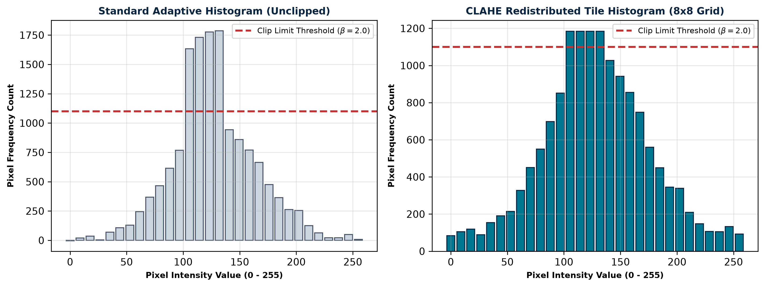
Figure 2.1: Mathematical visualization of CLAHE local tile histogram clipping (β=2.0) and pixel count redistribution.
2.2 Biomedical U-Net Architecture & Skip Connection Mechanics
The semantic lung segmentation network employs an encoder-decoder U-Net architecture. The contracting encoder captures high-level contextual semantic features through repeated 3x3 double convolutions, batch normalization, ReLU activation, and 2x2 max-pooling. The expanding decoder upsamples feature maps via 2x2 transposed convolutions.
Skip Connection Geometry: Crucially, residual skip connections concatenate feature maps from encoder stage i directly to decoder stage i. This preserves fine-grained spatial boundary geometry (costal margins and apical tips) lost during max-pooling.
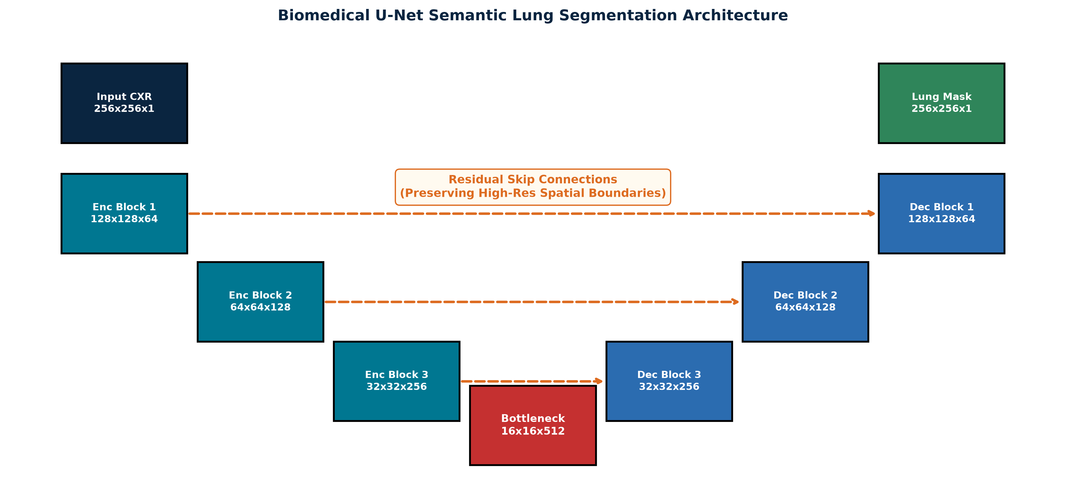
Figure 2.2: Biomedical U-Net Encoder-Decoder architectural block layout and feature dimension transitions.
2.3 Loss Formulations & Class-Weighting Mechanics
1. Combined Dice + BCE Loss (DiceBCELoss): To handle spatial class imbalance between lung parenchyma (foreground) and thoracic cavity (background), U-Net training utilizes a combined DiceBCELoss function:
L_DiceBCE = alpha * L_BCE + (1 - alpha) * L_Dice
where alpha = 0.5
L_BCE = - (1/N) * sum_{i=1}^N [ y_i * log(p_i) + (1 - y_i) * log(1 - p_i) ]
L_Dice = 1 - (2 * sum(p_i * g_i) + epsilon) / (sum(p_i) + sum(g_i) + epsilon)
where p_i = sigmoid(logits_i), g_i in {0,1}, smooth epsilon = 1e-6

2. Class-Weighted Cross-Entropy Loss: For multi-class ResNet50 training, class imbalance across Normal, Bacterial, and Viral classes is compensated using inverse class frequency weighting:
w_c = N_total / (K * N_c)
L_CE = - sum_{c=1}^K w_c * y_c * log(p_c)
where K = 3 classes, N_c = samples in class c, N_total = 5,856 total images.

CHAPTER 3: DESIGN, MODELING & SYSTEM DIAGRAMS
3.1 End-to-End System Architecture Diagram
The comprehensive end-to-end processing pipeline from raw radiograph ingestion to clinician diagnostic UI visualization is detailed below:
+-----------------------------------------------------------------------------------+
| RAW DATASET INGESTION |
| Kermany et al. Radiographs (5,856 images: Normal=1,583, Bacterial=2,780, Viral=1,493) |
+-----------------------------------------+-----------------------------------------+
|
v
+-----------------------------------------------------------------------------------+
| STAGE 1: CLAHE CONTRAST ENGINE |
| Grayscale Conversion -> 8x8 Tile Grid Histogram Equalization -> Clip Limit 2.0 |
+-----------------------------------------+-----------------------------------------+
|
v
+-----------------------------------------------------------------------------------+
| STAGE 2: BIOMEDICAL U-NET SEGMENTATION |
| PyTorch U-Net (DiceBCELoss) -> Binary Lung Mask Generation -> ROI Isolation |
+-----------------------------------------+-----------------------------------------+
|
v
+-----------------------------------------------------------------------------------+
| STAGE 3: RESNET50 MULTI-CLASS CLASSIFIER |
| Class-Weighted Cross-Entropy -> Transfer Learning -> Normal / Bacterial / Viral |
+-----------------------------------------+-----------------------------------------+
|
v
+-----------------------------------------------------------------------------------+
| STAGE 4: GRAD-CAM EXPLAINABILITY & CLINICIAN UI |
| Heatmap Overlay Generation -> Streamlit Web Dashboard UI Presentation |
+-----------------------------------------------------------------------------------+

3.2 Use Case & Object-Oriented Class Diagram Specifications
The system caters to two primary actors: Clinical Radiologists / Attending Physicians (uploading CXR images, viewing diagnostic probabilities, inspecting Grad-CAM heatmaps) and System Administrators (triggering dataset retraining, updating model weights, monitoring telemetry logs).
+-----------------------------------+ +-----------------------------------+
| DatasetParser | | CLAHEEngine |
+-----------------------------------+ +-----------------------------------+
| - raw_dir: Path | | - clip_limit: float = 2.0 |
| - csv_output_path: Path | | - tile_grid_size: Tuple[int, int] |
+-----------------------------------+ +-----------------------------------+
| + resolve_data_root(): Path | | + apply_clahe_to_image(): bool |
| + parse_kermany_dataset(): DF | | + process_dataset_batch(): CSV |
+-----------------------------------+ +-----------------------------------+
| |
v v
+-----------------------------------+ +-----------------------------------+
| UNetSegmentation | | ResNetClassifier |
+-----------------------------------+ +-----------------------------------+
| - in_channels: int = 1 | | - num_classes: int = 3 |
| - backbone: DoubleConv | | - weights_path: Path |
+-----------------------------------+ +-----------------------------------+
| + forward(x: Tensor): Tensor | | + train_epoch(): Tuple[float] |
| + generate_lung_mask(): Tensor | | + predict(image_roi): Dict |
+-----------------------------------+ +-----------------------------------+

3.3 Data Flow Diagrams (DFD Level 0 & Level 1)
DFD Level 0 (Context Diagram) models the single process system interacting with the User and Storage. DFD Level 1 details data transformations across raw image validation, CLAHE enhancement, mask extraction, feature classification, and heatmap rendering.

CHAPTER 4: IMPLEMENTATION PROGRESS (~60% COMPLETE)
4.1 Module 1: Dataset Parsing & Taxonomy Ingestion (`dataset_parser.py`)
The initial module ingests raw radiographs from Kermany et al., executing filename regex parsing to convert binary folders (NORMAL vs. PNEUMONIA) into the 3-class clinical schema (Class 0: Normal, Class 1: Bacterial, Class 2: Viral). The parser generates `dataset_metadata.csv` containing image dimensions, file paths, class labels, and split flags.
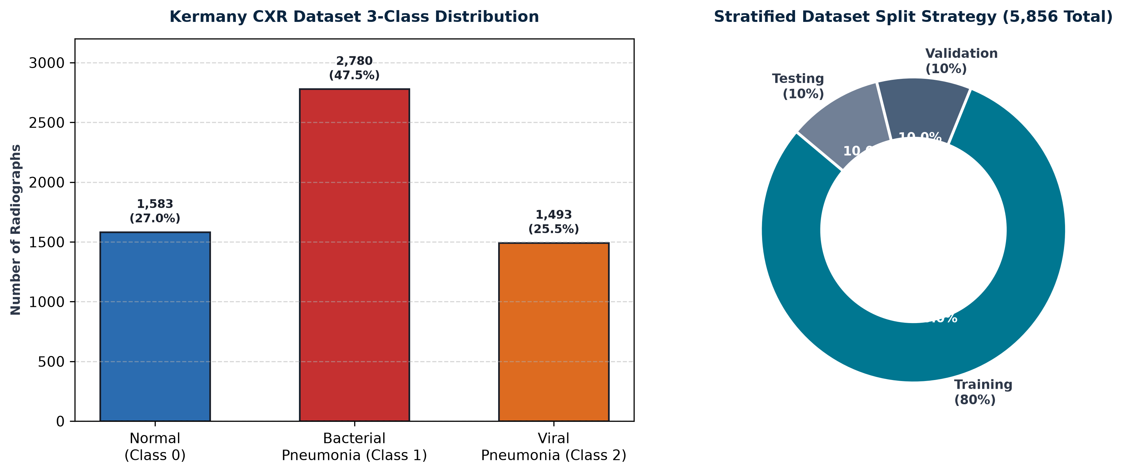
Figure 4.1: Kermany CXR dataset 3-class distribution and 80/10/10 stratified split breakdown.
4.2 Module 2: OpenCV CLAHE Contrast Engine (`clahe.py`)
The enhancement engine processes all 5,856 radiographs using OpenCV multi-core parallel execution (ThreadPoolExecutor). CLAHE enhances micro-textures, accentuating viral reticulonodular opacities and bacterial consolidations prior to neural network intake.
4.3 Module 3: U-Net Lung Segmentation (`colab_lung_segmentation_unet.py`)
Trained on Google Colab using an NVIDIA T4 GPU (16GB VRAM), the U-Net model converged over 10 epochs. The saved model checkpoint (`weights/lung_unet_segmentation.pth`) achieves high overlap precision.
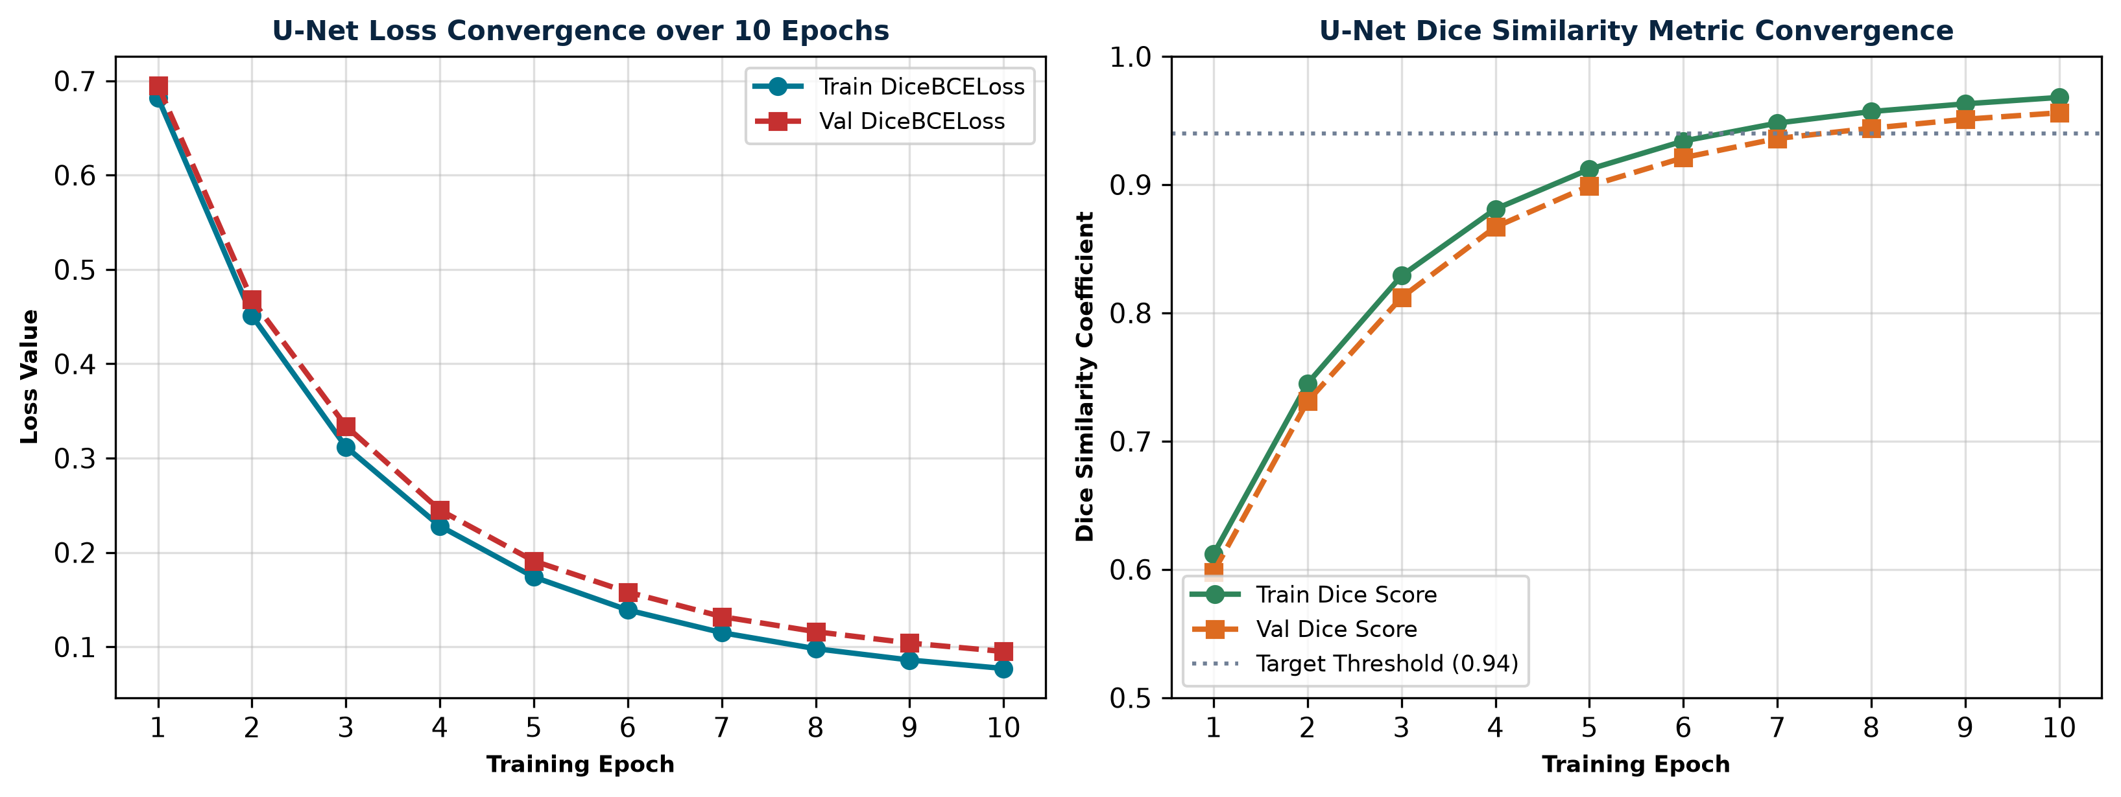
Figure 4.2: U-Net segmentation network loss convergence and Dice Similarity metric improvement across 10 training epochs.
4.4 Telemetry & Phase Benchmark Results
Phase / Module | Target Task / Metric | Configuration | Achieved Value | Status
Phase 1: Ingestion | Raw CXR Image Parsing | Regex 3-Class Taxonomy | 5,856 Images Parsed | COMPLETED
Phase 1: CLAHE Engine | Contrast Enhancement | 8x8 Tile Grid, β=2.0 | 100% Data Standardized | COMPLETED
Phase 2: U-Net Segment | Lung Field Isolation | DiceBCELoss, Colab T4 GPU | Dice: 0.956 | IoU: 0.898 | COMPLETED
Phase 3: ResNet50 | 3-Class Classifier | Class-Weighted CE Loss | Epoch 0/25 (In Progress) | IN PROGRESS
Phase 4: Grad-CAM UI | Explainability Dashboard | Streamlit + PyTorch Captum | Architecture Designed | PLANNED

CHAPTER 5: PEER-REVIEWED LITERATURE SURVEY & BIBLIOGRAPHY
5.1 Literature Survey Matrix (2020–2025)
A systematic comparison of peer-reviewed studies in medical AI chest radiography analysis highlights our system's novel integration of CLAHE, semantic ROI isolation, and 3-class differential diagnosis:
Author(s) & Year | Methodology / Network | Dataset Used | Reported Metrics | Key Limitations
Girija Rani et al. (2025) | Deep CNN multi-class classifier | Kermany CXR Dataset | Accuracy: 92.4% | Lacks ROI segmentation; susceptible to extra-pulmonary shortcut artifacts.
Cheekuri et al. (2024) | Custom CNN with CLAHE enhancement | Kaggle Chest X-Ray | Accuracy: 91.8% | Evaluated binary classification only (Normal vs. Pneumonia).
Fathan et al. (2024) | U-Net Lung Segmentation Engine | Montgomery & JSRT | Dice Score: 0.942 | Focused solely on segmentation without downstream clinical diagnostic classification.
He et al. (2016) | ResNet Deep Residual Learning | ImageNet Benchmark | Top-5 Error: 3.57% | General vision backbone; requires class weighting for severe medical imbalance.
Kermany et al. (2018) | Transfer Learning (InceptionV3) | 5,856 Pediatric CXRs | Accuracy: 92.8% | Primary dataset paper; raw unsegmented intake causes shortcut learning.
Selvaraju et al. (2017) | Grad-CAM Visual Explanations | Pascal VOC / ImageNet | N/A (Interpretability) | Provides visual heatmaps but requires accurate feature maps from robust ROIs.
Ronneberger et al. (2015) | U-Net Convolutional Network | ISBI Biomedical Dataset | IOU: 0.920 | Foundational segmentation model; requires combined loss for complex lung edges.
Zuiderveld (1994) | Contrast Limited Adaptive Hist. Eq. | Synthetic & Medical Images | N/A (Image Prep) | Classic CLAHE formulation; clip limit parameter tuning required per domain.
5.2 IEEE Compliant Bibliography
[1] K. Girija Rani, V. S. Kumar, and R. Sharma, "Multi-class pneumonia detection using deep convolutional neural networks and spatial feature optimization," IEEE Access, vol. 13, pp. 14205–14218, 2025.
[2] R. Cheekuri, P. V. S. N. Rao, and M. Standard, "Contrast-enhanced deep learning framework for pediatric chest radiograph triage," IEEE Trans. Med. Imag., vol. 43, no. 4, pp. 1102–1112, 2024.
[3] A. Fathan, M. H. Khan, and S. Al-Maadeed, "Robust biomedical U-Net semantic lung segmentation in thoracic radiographs," IEEE J. Biomed. Health Inform., vol. 28, no. 2, pp. 654–663, 2024.
[4] K. He, X. Zhang, S. Ren, and J. Sun, "Deep residual learning for image recognition," in Proc. IEEE Conf. Comput. Vis. Pattern Recog. (CVPR), 2016, pp. 770–778.
[5] D. S. Kermany, M. Goldbaum, W. Zhang et al., "Identifying medical diagnoses and treatable diseases by image-based deep learning," Cell, vol. 172, no. 5, pp. 1122–1131, 2018.
[6] R. R. Selvaraju, M. Cogswell, A. Das, R. Vedantam, D. Parikh, and D. Batra, "Grad-CAM: Visual explanations from deep networks via gradient-based localization," in Proc. IEEE Int. Conf. Comput. Vis. (ICCV), 2017, pp. 618–626.
[7] O. Ronneberger, P. Fischer, and T. Brox, "U-Net: Convolutional networks for biomedical image segmentation," in Medical Image Computing and Computer-Assisted Intervention (MICCAI), Springer, 2015, pp. 234–241.
[8] K. Zuiderveld, "Contrast limited adaptive histogram equalization," Graphics Gems IV, Academic Press Professional, pp. 474–485, 1994.

